MONGODB ASSIGNMENT -2
- Create a database named university and a collection named students. Insert multiple student documents with fields: name, age, department, and grades.
- Write a query to display all students who are in the Computer Science department.
- Write a query to update the grades of a student named Alice by adding a new subject programming with a grade of 93.
- Write a query to increment the age of all students by 1.
- Write a query to delete all students who are 23 years old.
- Write an aggregation query to group students by their department and calculate the average age in each department.
- Write a query to find all students who have scored more than 90 in any subject.
- Write a query to add a new field graduated set to false for all students who are in the Mathematics department.
9 .How can you retrieve only the name and department fields for all students, excluding the _id field?

Answers:-
1:
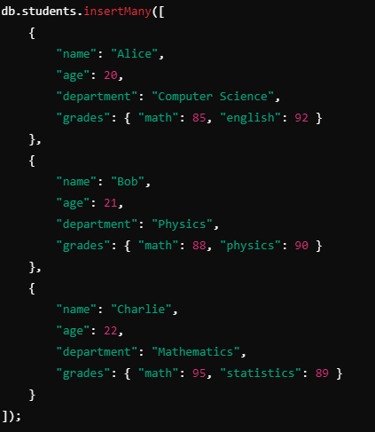
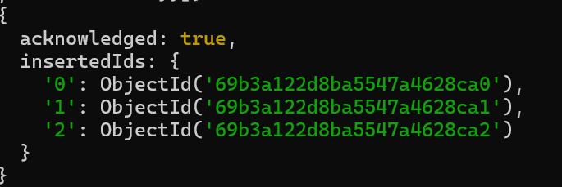
2:
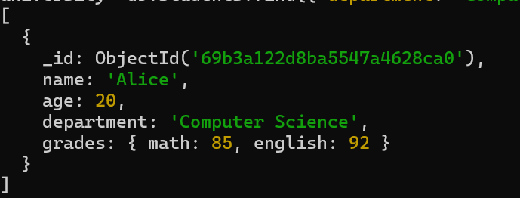
3:
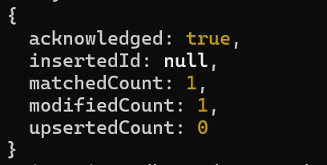
4:
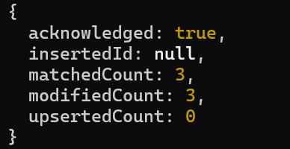
5:
6:
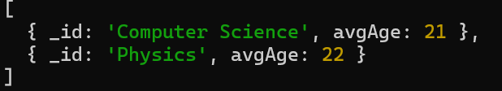
7:
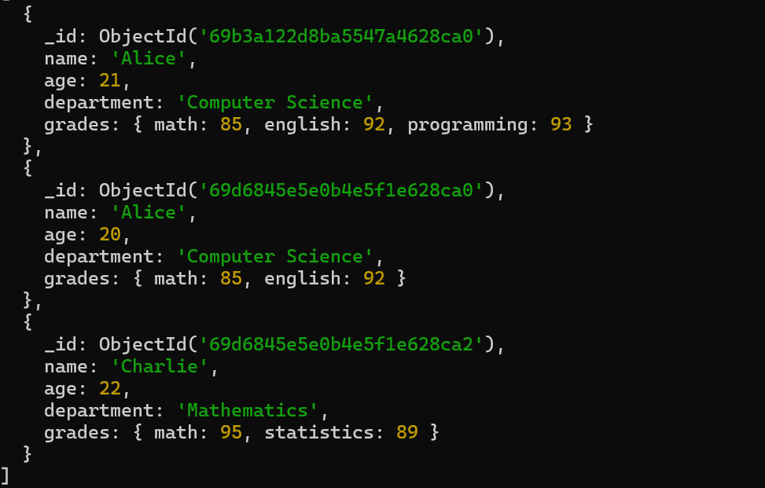
8:
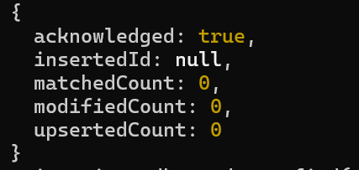
9:
